**Lab – 43: How to restart a device remotely with Intune?**

**Objective:** The objective of this lab is –

* To restart a device remotely with Microsoft Intune.

The Restart device action causes the device you choose to be restarted. The device owner is not automatically notified of the restart, therefore might lose work. Sometimes you need to restart the device remotely for security purposes. So, in this lab, we are going to restart a device remotely which is enrolled with Intune.

**Prerequisite:** EMS Enterprise Mobility + Security E5.

**Steps:**

1. Sign in to your Azure Portal, by using the link - **https://portal.azure.com/**. Enter your credentials and click Sign In.

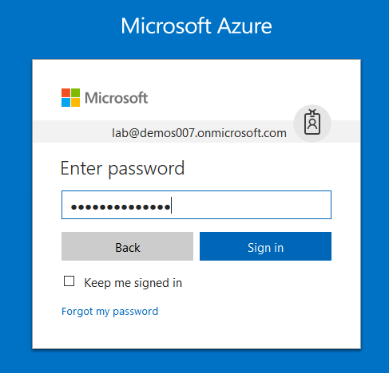

1. Microsoft Azure AD Dashboard will open.

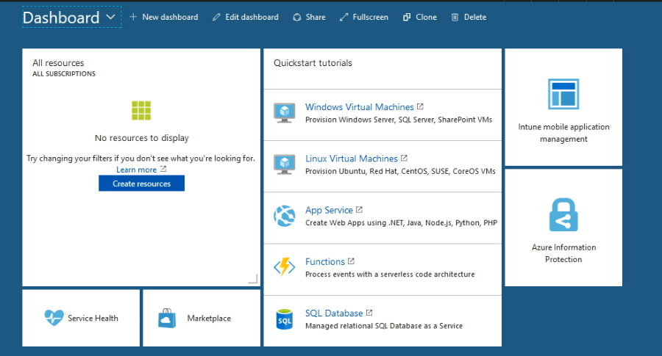

1. Open **Microsoft Intune** service from the left-hand side of the Azure portal.
2. Once you've opened the **Microsoft Intune** blade, select **Devices**.

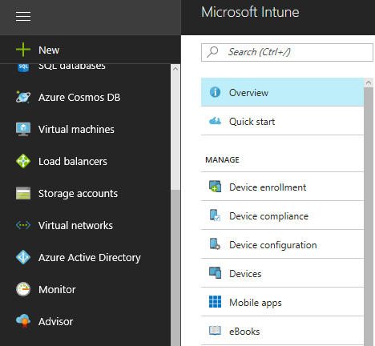

1. On the **Devices and groups** blade, choose **All devices**.

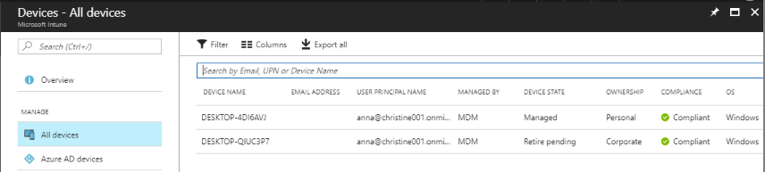

1. From the list of devices, you manage, choose a device.
2. Then a device details will be shown in the **Overview** blade. Select **…More** option from top right corner.

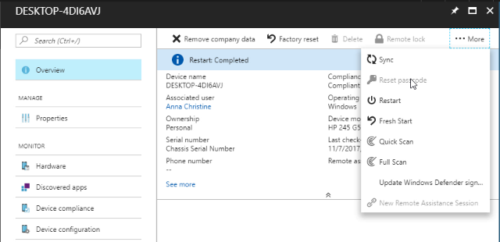

1. And, select **Restart**.
2. When you click restart a confirmation pop-up box will open. Click **Yes**, if you are sure you want to restart this device remotely.

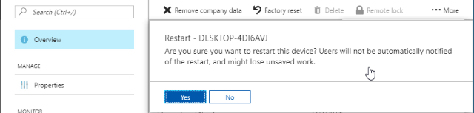

1. On clicking **Yes**, a restart request will initiate. And, at the top of the device details you can see the **Restart pending** message.

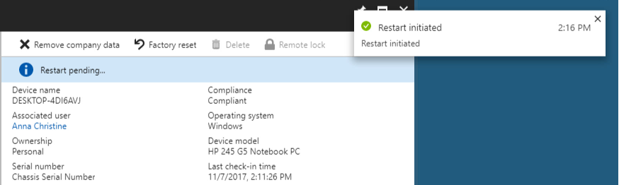

1. Then the device will restart and when the device will restart you can see the **Restart Completed** message.

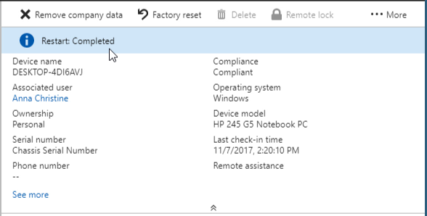

1. So, in this way you can restart a device remotely with Microsoft Intune.